# Museum Sequence Diagram

## Section 1: The Primary Presentation

# 

## Section 2: The Element Catalog

### 2.1 Elements and their properties

The end user represents the individual initiating the sequence to achieve the end result.

The browser is the web portal through which the end user access the application and sends/receives information.

The API Gateway serves to manage requests from the user and their related responses. It provides separation to facilitate the microservice structure.

The authentication element authenticates the user as approved to use the system in the event a request is made without authorization.

The DispatchServlet manages the requests and their associated responses between the gateway and specific service controllers.

The MuseumController then processes the query transmitted through the URL so that it can be associated with an instance of the MuseumSvc.

The MuseumSvc then sends the appropriate method to the MuseumDao class, which ultimately retrieves data from the DB2 t_museum.

### 2.2 Relations and their properties

The relations within the sequence diagram fall under the categories of time or instance. Vertically, the diagram depicts the progression of execution to achieve the goal of the sequence. Horizontally, it depicts the flow of information between the instances.

## Section 3: Context Diagram

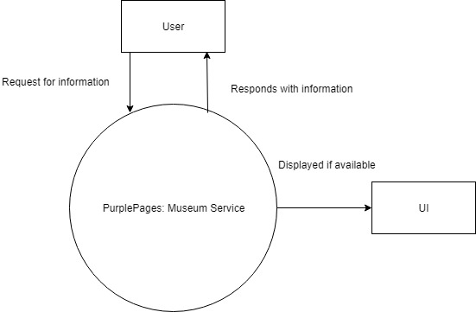

## Section 4: Variability Guide

There are no variation points for this diagram.

## Section 5: Rationale

This diagram represents the use of an API to retrieve data from a database. This sequence uses a RESTful API design as it is essential to have a separate client and server system to allow for microservices to be added, edited, and removed on the fly.